Content

Skill and feasibility in some software project examples 2
SmartHG international project 2
Client-server automation supervising control system RealGaz 3
GLE_GTS graphical libraries 4
PV_Online project 6
PageView project 7
Overview 7
The Visualization and computing of huge array of data 7
CompView (technology for the model create and control) 9
Overview 9
Technology description 9
Object Editor 10
Wide area of applications. 10
1995 - 2001 years projects 12
Set of programs for fire propagation modeling and for control of resource of fire fighting teams on ships 12
The path modeling and optimization program project 14
2001 year. Education html program TTD. 15
Our partner projects 15
Fuel Cells research 15
Multimode training and testing computer-aided complex for the ship energy equipment management 16
Outstanding features 16
3DiconStudio project 20

Skill and feasibility in some software project examples

SmartHG international project
Currently going project.
The SmartHG is acronym of the project. Full name is Energy Demand Aware Open Services for Smart Grid Intelligent Automation.
Project consortium consists of 11 international companies from several European countries.
Project URL: http://smarthg.di.uniroma1.it/

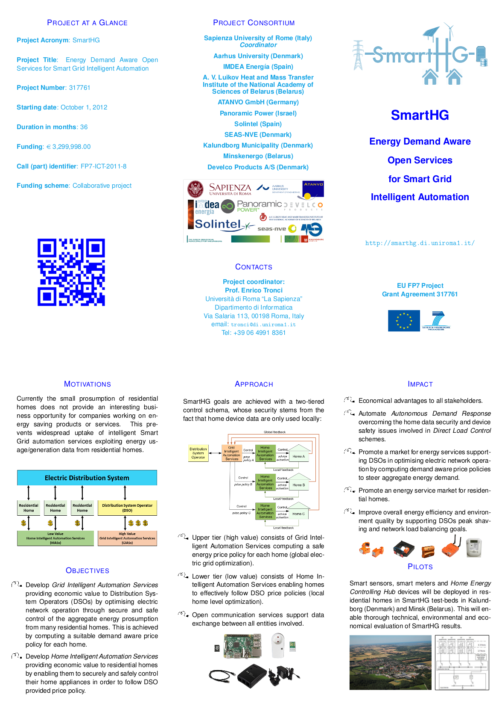

Client-server automation supervising control system RealGaz

The system was created in 2012 by order of GAZPROM-InformTransGas company.
The system consists of several modules:
- SINFServer – Server module used for connection to real time SCADA DB – RTAP/GOFO2;
- Dispatcher – Multiplatform client module.
- Several internal tools library.
The system intended to work under Unix-Solaris OS. The client modules may be used under Windows.

Project URL http://informtransgas.ru/sp-realgaz.html

GLE_GTS graphical libraries

We have created new OpenGl based libraries to operate with 3D Constructive Solid Geometry on compound objects and to realize special 3D effects such as extrusion function for piping system visualizing and many more useful graphical actions.

The example of realized 3D compound object subtraction function is shown at the pictures 1,2,3:

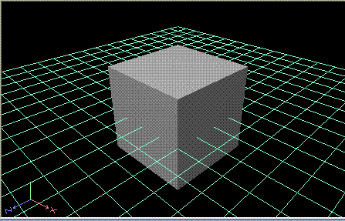
Picture 1. The main Cube object

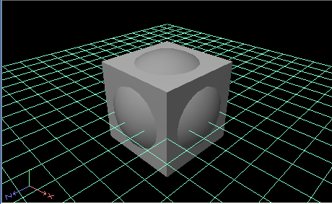
Picture 2. The second Sphere object is added.
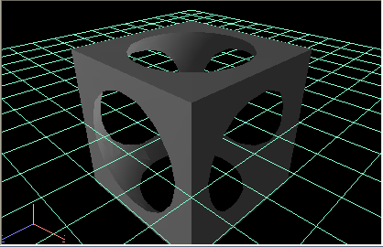
Picture 3. The resulting subtracted compound object. This makes Cube minus Sphere constructive geometry subtraction operation.

Several examples of program products that use our libraries are shown at the next pictures.

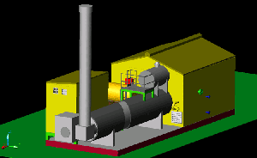
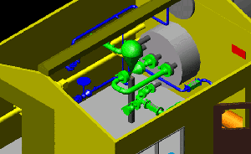

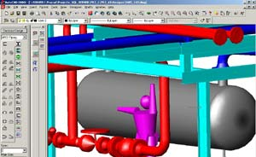

PV_Online project
The project is realization of several multiprocessing OCXs and appropriated environments. It had finished on 2003. The main aim of the project was creation of DCOM linked OCXs to show huge data flows online.
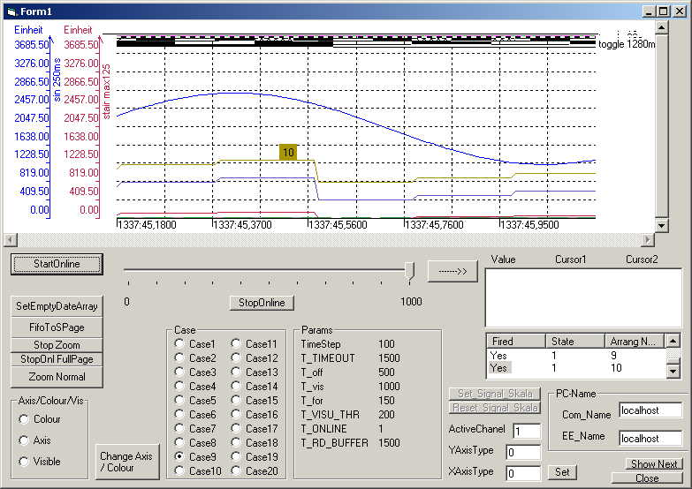

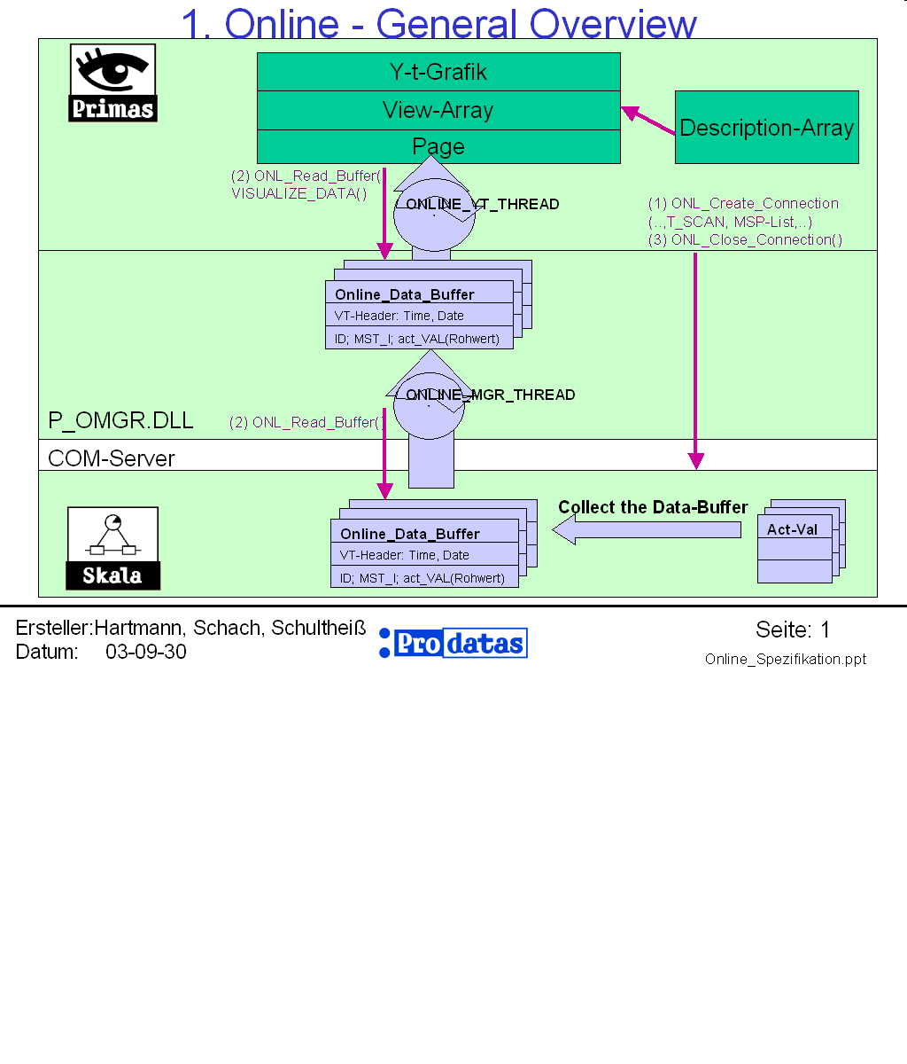
Realized by us part of main project is shown at picture above inside red ellipse.

PageView project

Overview
This project was long time project. It had started in 1995 by order of Mercedes-Benz, Germany. The intermediate customer was Prodatas Gmbh, Germany. The main point of project was the visualization of huge volume of data. The project was created on Visual C++ 4,5,6 versions. Up to 10 programmers were involved in works under this project.

The Visualization and computing of huge array of data
The technology completes of several OCXs with special functions inside.
The technology permits:
- To visualize and compute of huge volume of data (more then 100 billions of values in several formats) with high performance. The special computing methods are using to grow performance;
- To zoom the data through computing zooming too far in deep;
- The selective visualization of data with special statistic methods;

- To do the special recompile of data;
- To make the reverse data depends;
- To do the flexible tuning to data formats. To use a lot of data formats such as ODBC, DAO, ADO, XML and more;
- To make multi-channel data access.
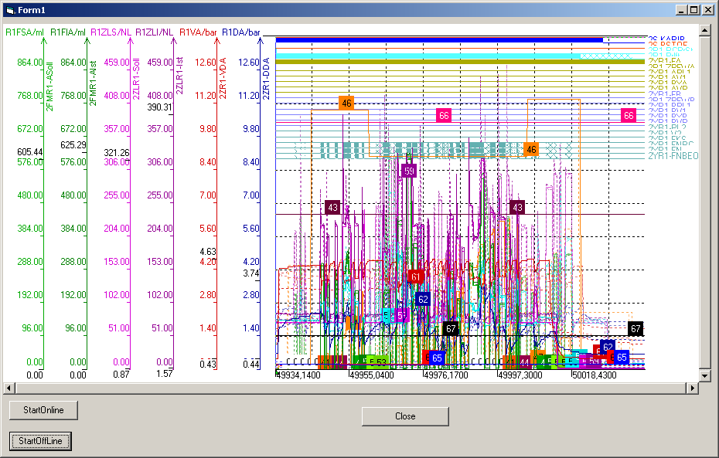

CompView (technology for the model create and control)

Overview
The main aim of the project was the technological scheme creation, edition and modeling on big volume of real data in offline and online modes. The project was created on Visual C++ 4,5,6 versions. Up to 10 programmers were involved in work.

Technology description
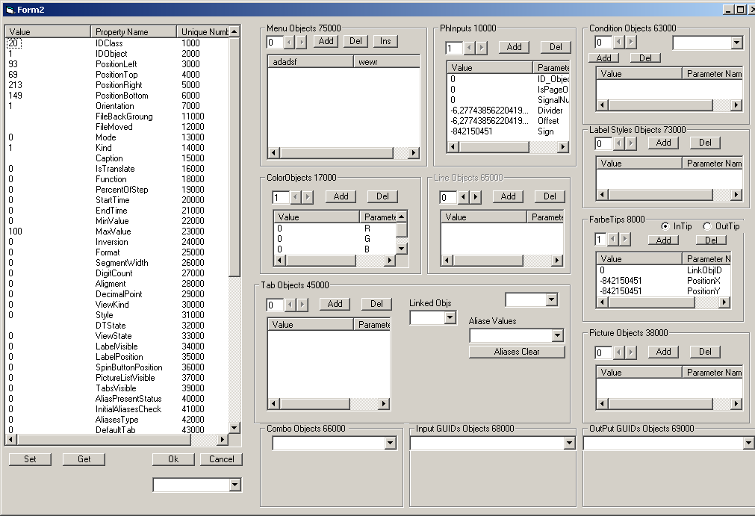
This is full closed and ready-made programming technological cycle of scheme edition and dynamical data visualization in real-time mode. A lot of properties for each scheme object are using.

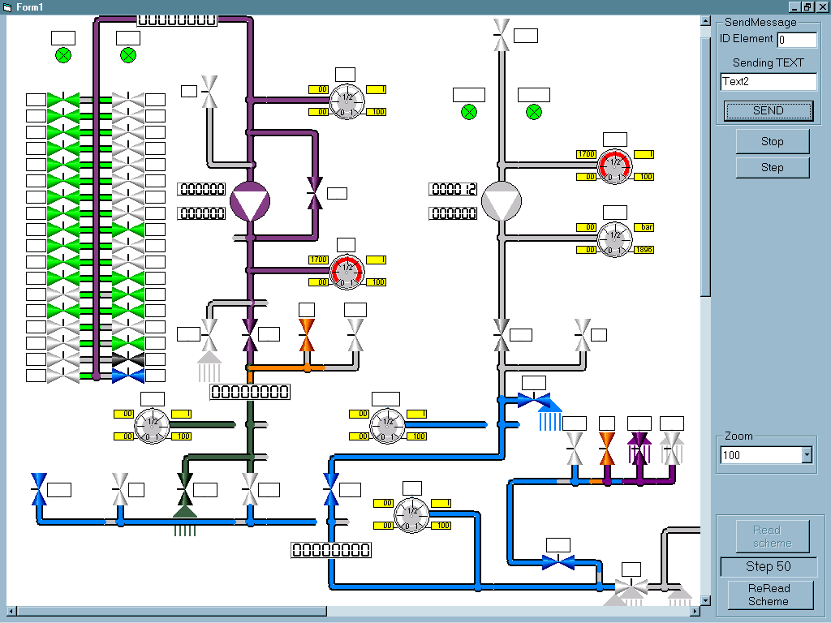

Object Editor

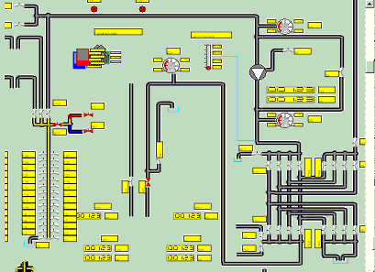The powerful build-in editor of objects permits the almost of all modern existed editing features.

Wide area of applications.

For car building technology
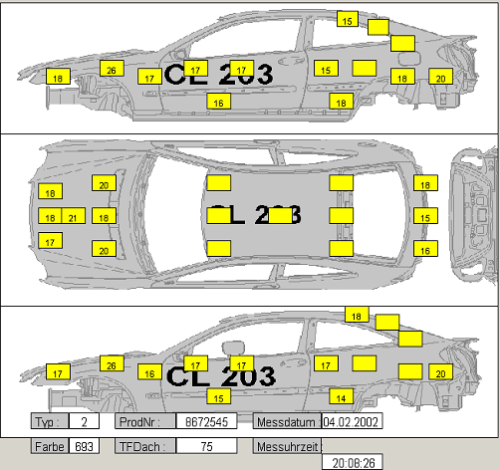

And up to energetically-economically analysis of regions using
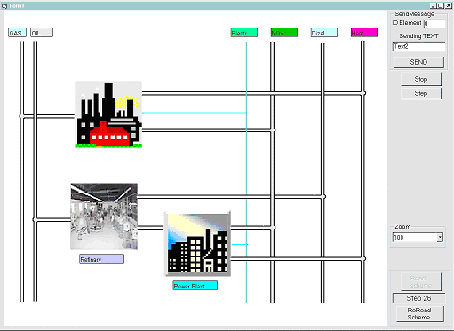

The all above describes is currently finished projects.

1995 - 2001 years projects

Set of programs for fire propagation modeling and for control of resource of fire fighting teams on ships

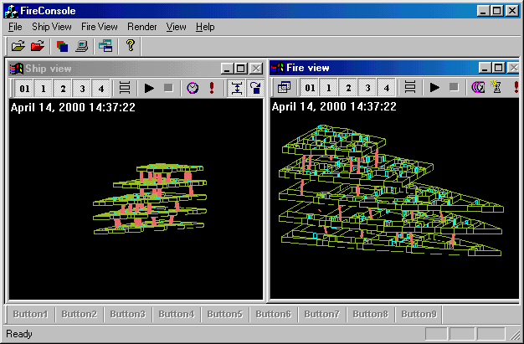
The set includes the 9 programs with the elements of artificial intellect for prompt to operator the optimized solutions. Programs have the 3D user interface and use COM-DCOM links for synchronize internal processes.
For edit sequence of fire fighting teams tasks the powerful graphical internal editor is used. In additional the program set includes big database of resources. The behavior of emergency teams are modeled and controlled by the several tasks type such as simple task, procedure, case module, branch, call back processes and more. For convenient modeling the scenarios of procedures are presented.
Real-time visualization of processes is usefully for operator’s work.
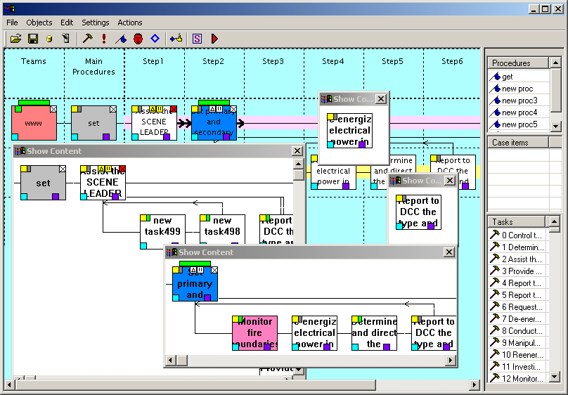

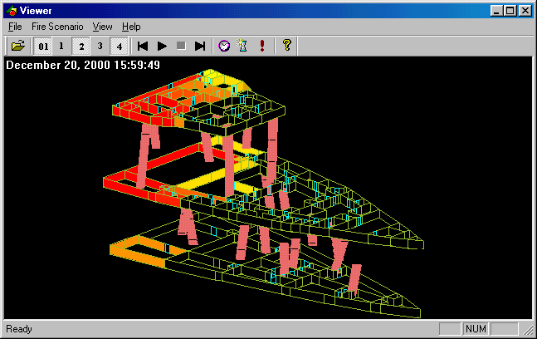

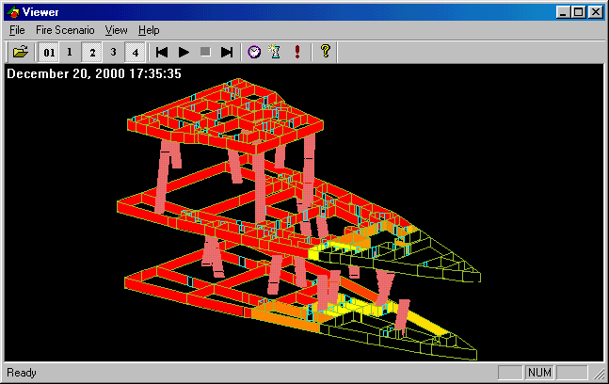

Project duration about 3 years. Up to 15 programmers were involved in works. C++ 5,6 language. Window based operation system.

The path modeling and optimization program project

The project was developed by order of Institute of Medical Cybernetics, MD, USA. The project includes the several program modules. For instance the following program works with real geographic maps and has the 3D Interface, OpenGL based.
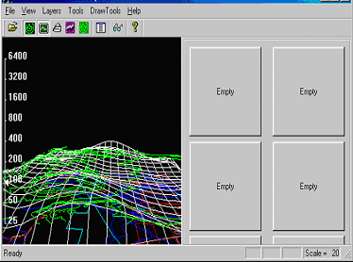

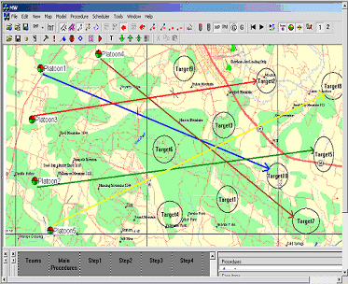

The next program uses real geographic maps for modeling the behavior of groups. The path optimization is applied for operator help purpose.

The program can calculate the several parameters of maps and areas.
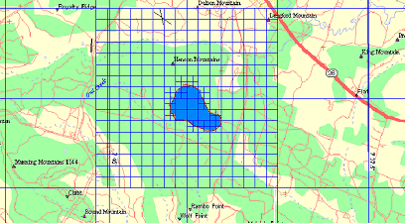

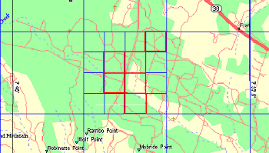

2001 year. Education html program TTD.

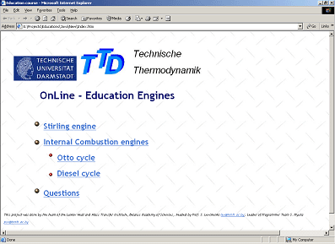
Was developed by order of Technical University of Darmstadt, Germany. The project includes the several dynamical elements on Java.

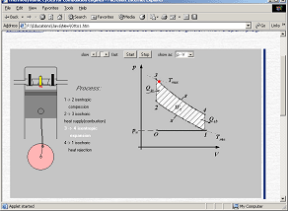
The project development duration was 6 month. Four programmers were involved in works.

Our partner projects

Fuel Cells research

We have now new technology for CVD growth of carbon nanotubes filled by Pt (or Ni) on stainless steel bipolar electrodes for PEM fuel cell (now 100 mm diameters with plan - up to 200 mm next 6 months).
Also we start technology research on high temperature solid oxide electrolyser (SOEC) and SOFC with forming electrolyte by plasma.
Current targets - 10 kW PEMFC and 10 kW SOEC to end of year and large scale nanocatalysts production on base of carbon nanotubes (carbon SWNT) in CVD reactor.

PEM - proton Exchange membrane
SOFC - Solid Oxide Fuel Cell
SOEC - Solid Oxide Electolyser
CVD - Chemical Vapour Deposition
SWNT - Single Wall Nano Tubes

Multimode training and testing computer-aided complex for the ship energy equipment management

IT IS DESIGNED for the perfection and maintenance of the ship power stations operation personal skills in order to decrease equipment accident rate and ware and therefore reduce its repair and recovery costs, to boost equipment availability coefficient and its operational safety, as well as fuel economy and decline the hazardous exhausts in the environment thanks to the skillful, conscious confident equipment management.

Outstanding features

COMPLEX MULTIPURPOSE NATURE introduces into the training process all equipment components up to the “smaller screw” and permits to train actions in details including all equipment (aggregates, power unit) management activities as an entire system, what is possible thanks to the hierarchical equipment structure (Picture 1).
Picture 1. Complex structure

The structure similar to the operation personal training is multidimensional and can be represented as a cube divided into three parts: on each of three intersected planes are situated education types, devices and modes. Each of 27 cube’s parts represents simulator type. Each type can be represented of any number of simulators. Each simulator consists of several exercises.
The greatest concretization and physical similarity is assured on the level of an individual mechanism. On the functional & technological equipment level the mechanism is a single element which is simple to handle; on the aggregate level the operation of some functional & technological equipment groups is considered as normal and is represented in generalized manner.
THE MULTIMODE permits to organize the training process for any equipment in all modes: from start up preparation to elimination of faults or halts. In this context it provides for training in all phases of decision making: planning, monitoring & evaluation, diagnoses and forecasting. All specific equipment simulators of one cube’s plane are using one multimode mathematical model, which responds to all trainee actions adequately to the object.
The used simulation method is based on the representation of power unit sets by the elementary groups with the known mathematical description; the links between them are described with the algebraic equation system, which reflects their mutual impact. This method is adequate to the classic formation of the differential equation system, which describes the processes taking into account all necessary interconnections, and also to the numerical solution of such a system.
The high level of formalization of composing the math model, thoroughly selected and structured mathematical procedures and its application software realization permit to operate math models, which are consistent with differential equation systems in the order of some hundreds both in normal and accelerate process speed.
Pedagogical trend is supported by all classic training methods: lectures provide knowledge; «hands on» training provides skills; tests (exams) verify the work readiness.
Lectures (study) are made by the exercise execution demonstration followed by the comments and/or by the previous observation of simulator reaction to the different student’ reactions.
Training (practice routine) is a personal exercise execution with guide line in the form of scroll windows as «Action control»; there is also a possibility to access the computer help with the key «Help».
Control is an individually executed exercise without help or instructions, but after task execution wrong actions are registered and stated in the form of list or integrated estimation.
The Complex has a registration system automatically maintaining a registration log for personal training on the simulators and for the statistical analyses of personal training.

Steam turbine set-up
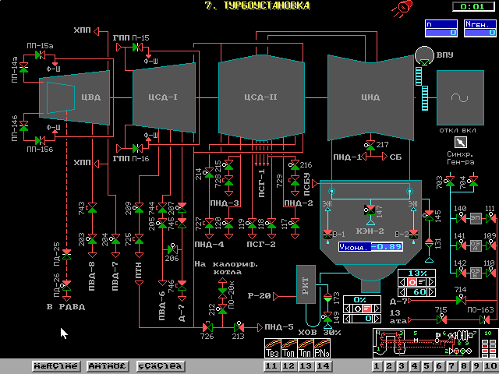
Different tasks of training
Different modes of training

Steam distribution system
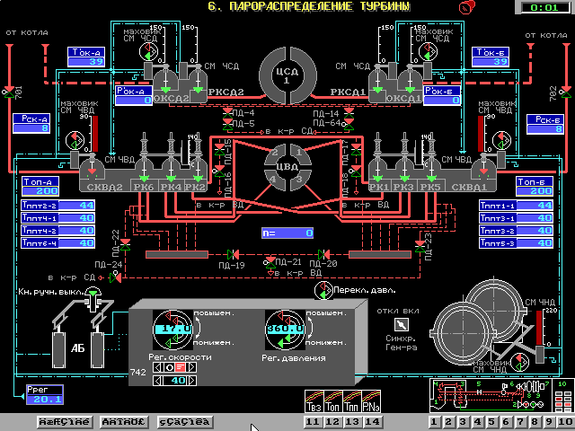

Mechanical condition of turbine

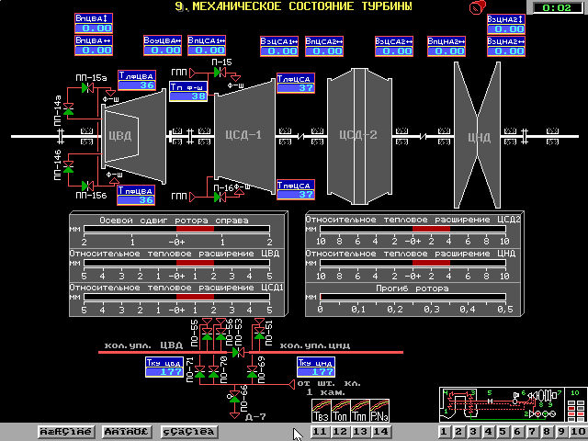

3DiconStudio project

The main aim of project is creation of 3D Scene building software by OpenGL and Gle-gts graphical library based. The project includes 7 subprojects. The Gle-gts library is own developed graphical library with unique set of functions. Three programmers have been involving in works.

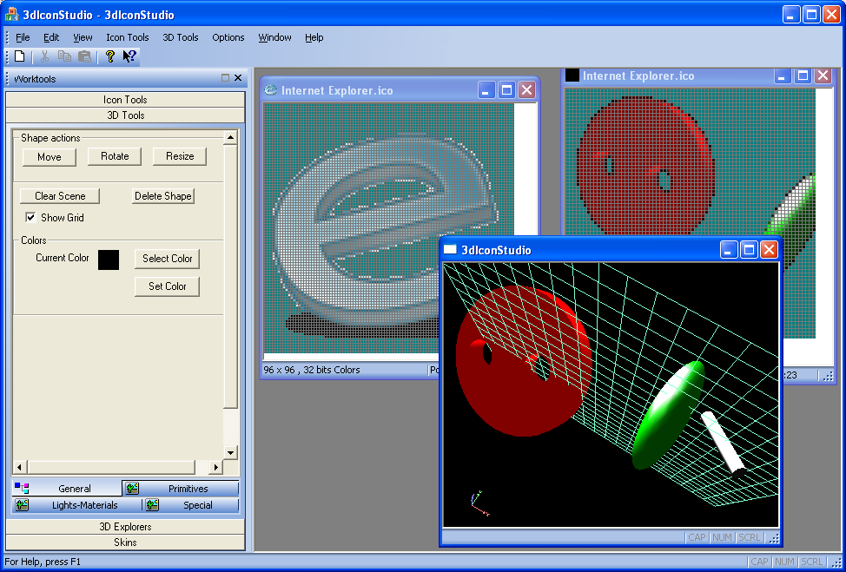

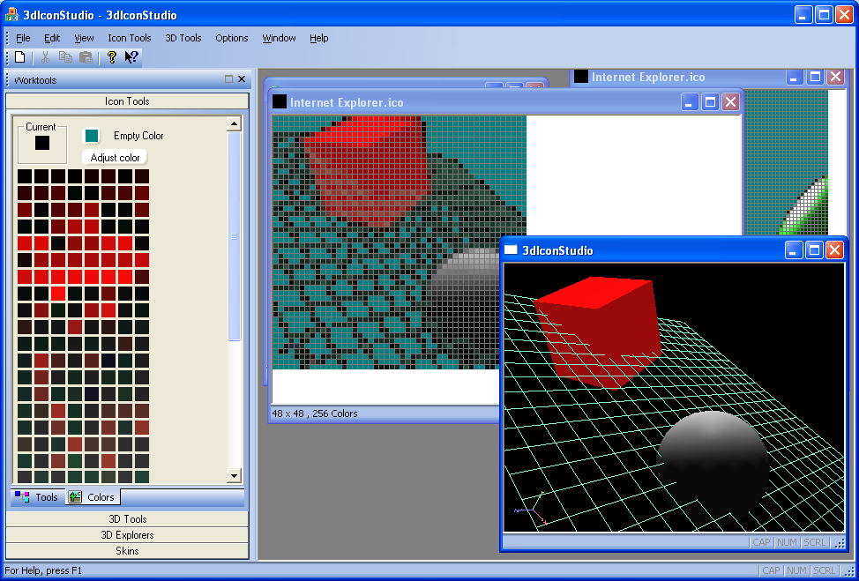

Project includes Constructive Solid Geometry mathematic with Boolean volume operations, Extrusion of arbitrary contours by arbitrary paths, lot of 3d shape primitives and standard tools for editing operations with textures and color-lighting control ability. In additional project realizes many of icon-cursor editing operations, including just-in-time from 3D scene view icon creating features. The several polygonal mesh building functions are used (e.g. Delaunay triangulation etc).

